Andrew Burke

Student id 10243828

Q1

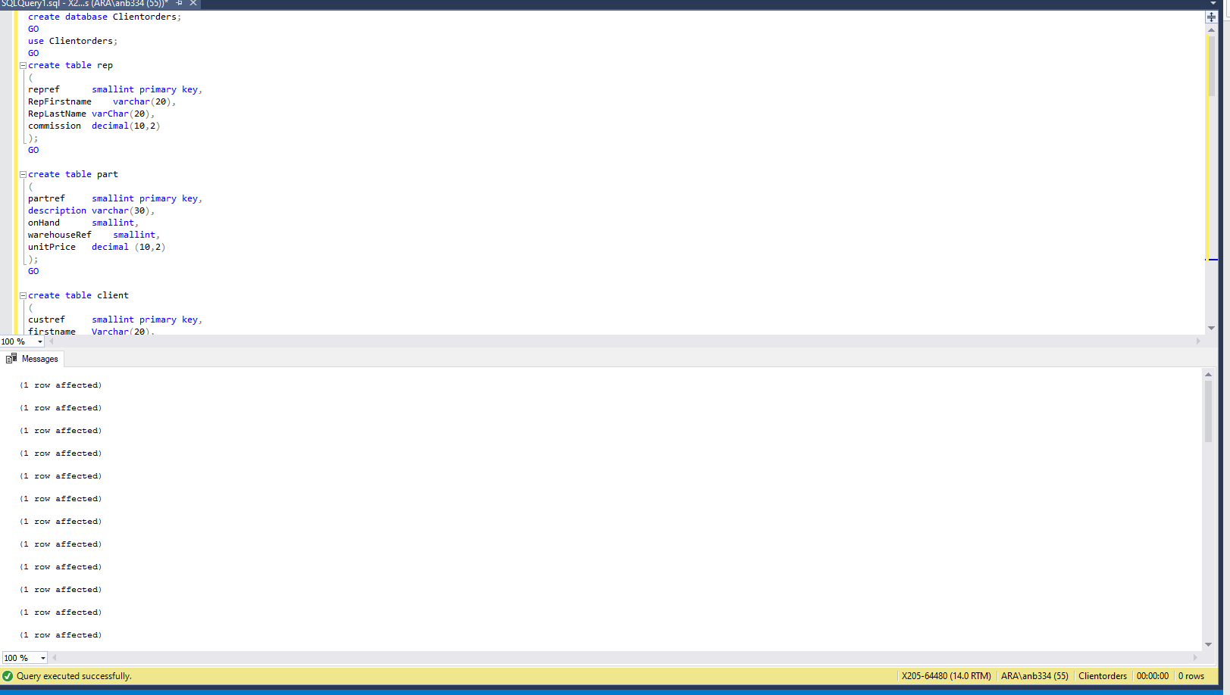

Q2

select lastname, firstname, city

from client

where city = 'Dunedin'

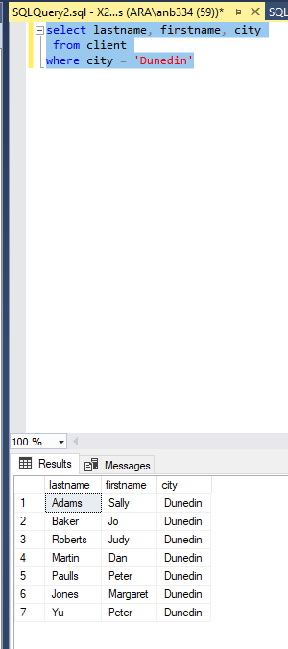

Q3

select firstname, lastname

from client

where lastname like 'j%'

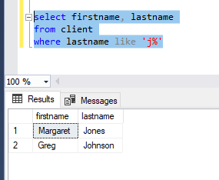

Q4

select firstname, lastname, balance

from client

where balance between 50 and 150

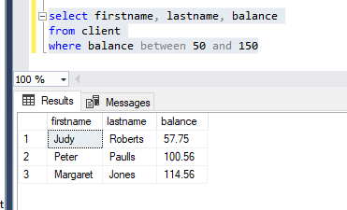

Q5

select firstname, lastname, city

from client

where firstname ='Mary' and lastname = 'Nelson'

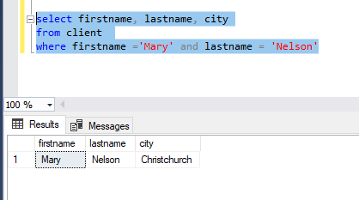

Q6

select firstname, lastname, balance, city

from client

where balance < 200 and city = 'dunedin'

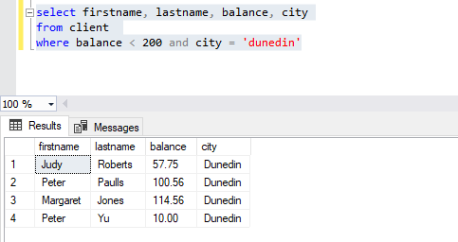

Q7

select custref,creditlimit, balance, sum (creditlimit - balance) as newbalance

from client

group by custref,creditlimit, balance

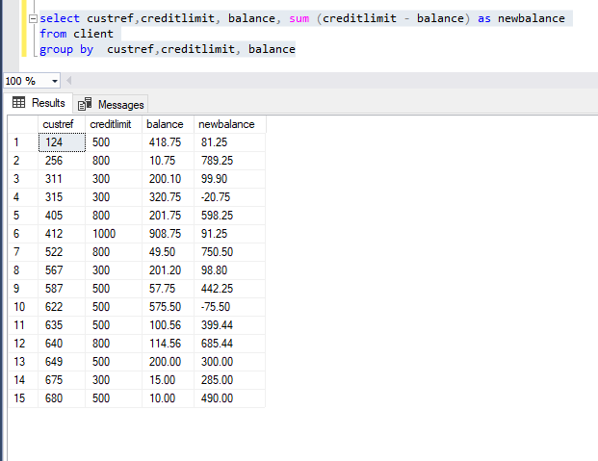

Q8

select custorder.orderref, partref, quantity, quotedprice,sum (quantity \* quotedPrice) as linetotal

from custorder

join orderline on orderline.orderref= custorder.orderref

group by custorder.orderref, partref, quantity, quotedprice

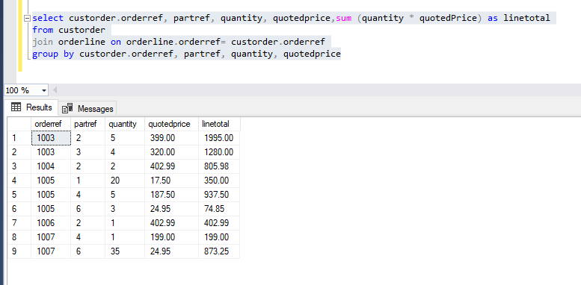

Q9

select orderref, orderdate

from custorder

where orderdate > '1999-06-01'

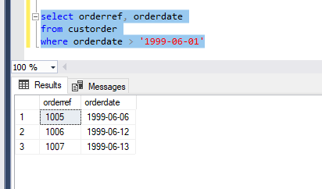

Q10

select city, count(\*) as numberInEachCity

from client

group by city

having count(city) > 3

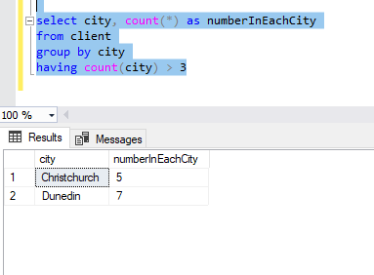

Q11

select rep.repref, sum([balance])as totalBalance

from client

join rep on client.repref = rep.repref

group by rep.repref

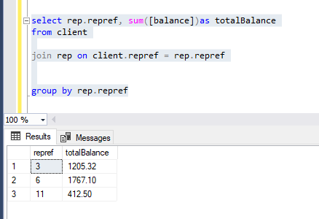

Q12

select city,max(balance) as MaximumBalance

from client

group by city

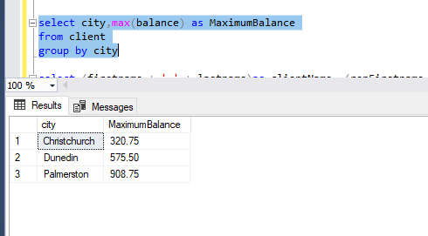

Q13

select (firstname + ' ' + lastname)as clientName, (repFirstname + ' ' + repLastName)as RepName

from client

left join rep on rep.[repref] = client.[repref]

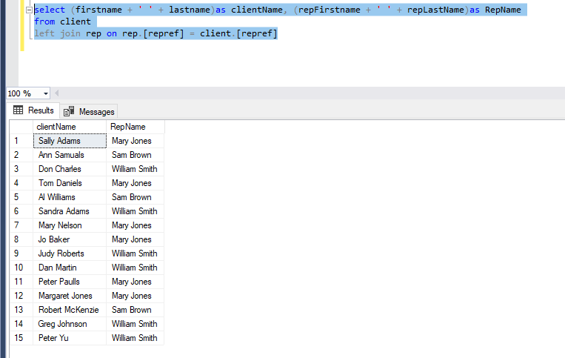

Q14

select orderref, firstname, lastname, orderdate

from custorder

left join client on client.[custref]= custorder.[custref]

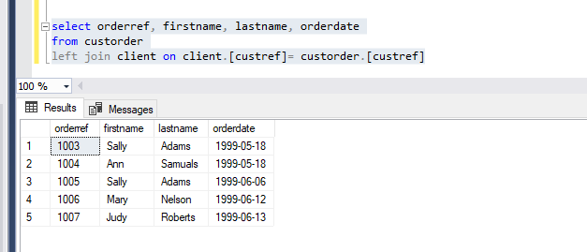

Q15

select orderref, [description],[onHand]

from [dbo].[orderline]

left join [dbo].[part] on part.[partref] = orderline.[partref]

where orderref = 1007

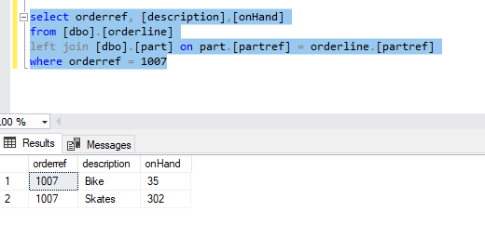

Q16

select orderref, [description],quotedprice[quotedPrice], quantity

from [dbo].[orderline]

left join [dbo].[part] on part.[partref] = orderline.[partref]

order by description, orderref

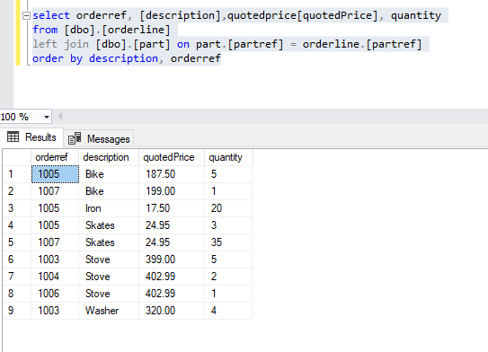

Q17

select orderref, [description],quotedprice[quotedPrice], quantity

from [dbo].[orderline]

left join [dbo].[part] on part.[partref] = orderline.[partref]

where quotedPrice > 200

order by quantity desc

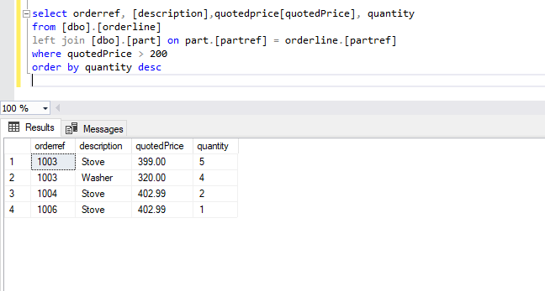

Q18

Select orderref, orderdate, firstname, lastname, description,unitprice

from custorder

left join client on [dbo].[custorder].[custref]= client.custref

right join part on part.partref = [partref]

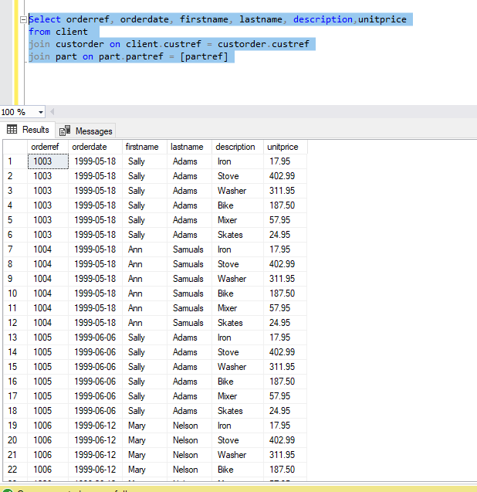

Q19

Select orderref, orderdate, firstname, lastname, description,unitprice

from client

join custorder on client.custref = custorder.custref

join part on part.partref = [partref]

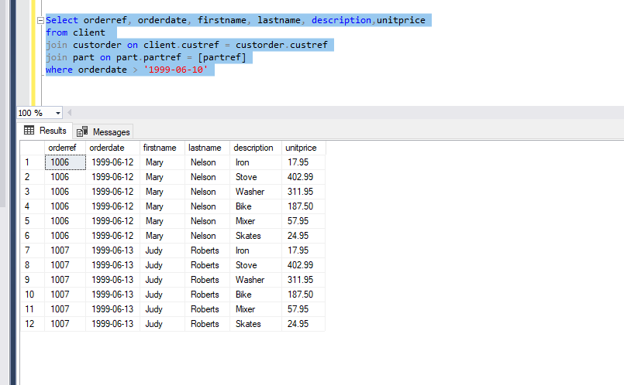

Q20

Q21

Q22

select custorder.orderref,sum (quantity \* quotedPrice)as TotalLineTotal

from custorder

join orderline on orderline.orderref= custorder.orderref

group by custorder.orderref

